Task 1:

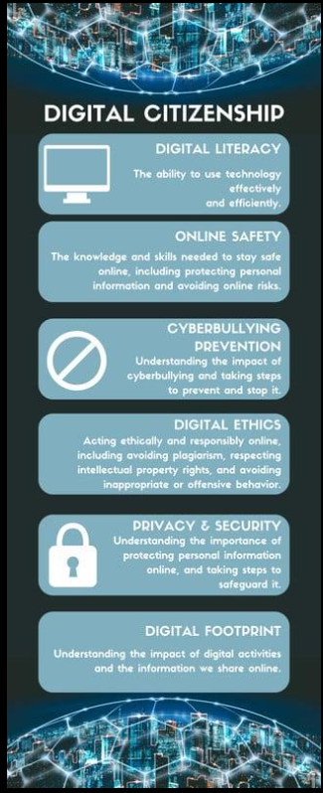

Brief Task description:
For my presentation task, I used Canva as the design tool. Canva is a user-friendly online platform that provides a wide variety of templates, graphics, and design elements, making it easy to create professional presentations. I selected a clean and modern template to ensure my slides looked organized and visually appealing.
My presentation focuses on Digital Literacy and Online Safety. It includes key topics such as the importance of digital skills, safe internet practices, common cyber threats, and ways to protect personal information online. I used icons, images, and minimal text on each slide to make the content easy to understand and engaging for the audience.
One thing I found particularly interesting while using Canva was the availability of customizable templates and design elements, which helped me enhance the overall look of my presentation. However, I initially found it a bit difficult to choose the most suitable design and layout from so many options. Over time, I learned how to maintain consistency in colours, fonts, and formatting, which improved the final outcome of my presentation.

